PUREGANIC MORINGA LEAF POWDER / TABLET FAQ

- What is PUREGANIC MORINGA LEAF POWDER / TABLET ?
  - It is the powder of drumstick tree (also known as Saragvo / Shevga/ Sahjan) leaves.also available in the tablet form.

- Why is moringa called superfood?

  - 20 Amino Acids including 8 Essential Amino Acids
  - Omega 3,6 & 9
  - OVER 90+ NUTRIENTS
  - 46 Anti- oxidants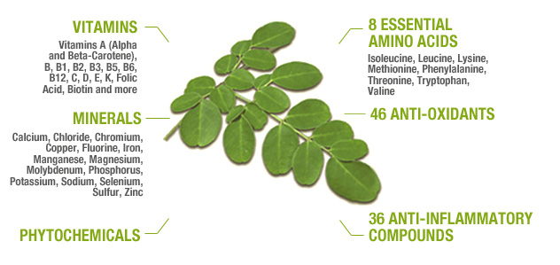

  - Moringa is declared as one of the top 20 super foods by World Health Organization.
  - According to Ayurveda Moringa cures and prevents 300+ disease

- Why use Moringa?
  - It is a must for vegetarians as it contains Omega 3, Omega 6 and Omega 9 which vegetarians do not get through their daily food intake.
  - Certain essential Amino Acids found in meat and fish are present in moringa.
  - It is a powerhouse of nutrients.
  - It’s a tree of Indian origin and so most suited for Indians and Indian climate.

- Why is it a powerhouse of nutrients?
  - It is packed with proteins.
  - Contains 20 amino acids.
  - 46 antioxidants.
  - High in Iron, Calcium, Potassium, Folic Acid.
  - Rich in vitamins A, E, B1, B2, B3, B5, B6, C.

- Benefits of Moringa Powder?
  - Anti-inflammatory, Anti-oxidant, Anti-fungal, Anti-aging, Anti-Tumor, Anti-ulcer
  - Reduces wrinkles.
  - Controls cholesterol.
  - Acts as an Antidepressant.
  - Increases metabolism, joint health, sugar control, brain powder.
  - digestion, immunity and muscle mass.
  - Improves Cardiac health, liver health, skin health.
  - Help to lubricate the joints which reduces joint pains.
  - Keeps hormonal balance and blood pressure in check.

- Who should not use?
  - Pregnant women should NOT use. (Must use after giving birth)

- Who can take Moringa Powder
  - Right from baby starting first food other than milk to senior citizens everyone except pregnant women.

- I don’t like the taste of Moringa Powder. How can I use?
  - U can disguise the taste by mixing it in green chutney or with honey.
  - Some even mix it with buttermilk. If still you can’t manage the taste then switch over to PUREGANIC MORINGA TABLETS

- Is there anything side effect?
  - This is natural product. Its just like any other food. So there are no side effects. ! out of 100 may experience loose motion for a day or two. Don’t worry or panic. This happens as your body is cleansing and will stop shortly.

- When I eat Moringa Powder on empty stomach I get nasty tasty burps the entire day?
  - This is normal and may happen with 10% people. Don’t worry, take Moringa Powder after meals.
  - When taken on full stomach effectiveness of the powder might be reduced by 20% but it is still effective.

- Why do you advice to take 2 glasses of water or any other fluid with Moringa Powder?
  - We want this powder to be absorbed in the intestine to give maximum result

- Nutrient comparison of Moringa Powder with other foods
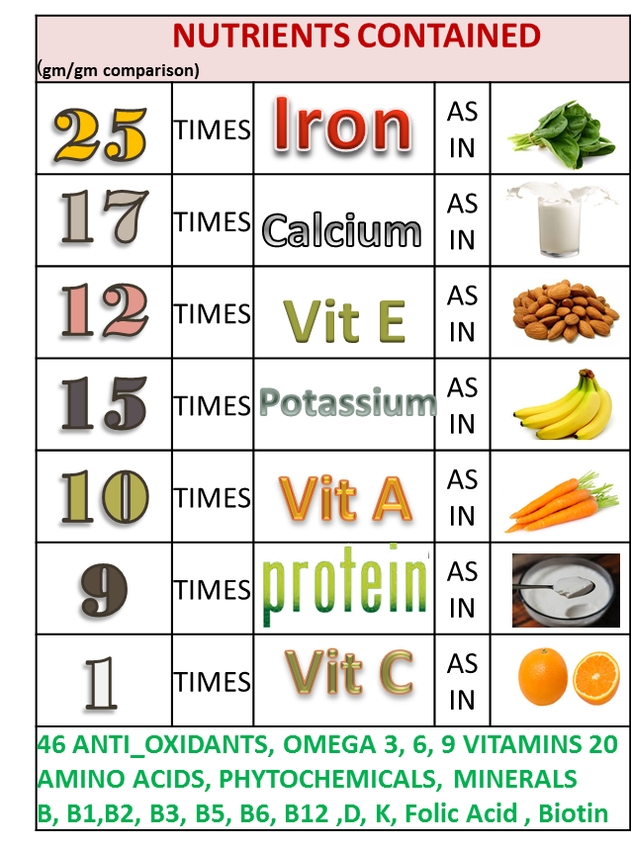
How To Use

MORINGA POWDER / MORINGA LEAF TABLET
Daily dose : 3-5 grams, 1-2 teaspoon preferably on empty stomach with 2 glasses of water or any other fluid like green tea etc.

How to use
For Two days take ½ tspand drink 2 glasses water or any other fluid .This is to be done on empty stomach. Then gradually increase to 1 tsp, 1 ½ tsp and 2 tsp. Maximum dose is 1 tsp twice a day. Adjust the dose as per the way it suits your body from 1 to 2 tsp..

Can mix with
- honey / buttermilk / soup.
- lukewarm honey lemon water.
- cooked food / salad /chutney
- can Sprinkle in Dal, Sabji, Salad, Soups, Dips, Cereal, Health Juice, Baby Food Add to soups, dips, sandwich spreads, patés casseroles, vegetables, smoothies, or just about anything you eat
- Some people make a "green sauce" by mixing some of the leaf powder with oil. .
- You can sprinkle it on rice, casseroles, salads, or mix it right into salad dressing.
- Put it in omelettes, muffins, biscuits and breads.
- U can eat it with quinoa, with butter, garlic, and maybe a dash of salt.
- The powder can be used to make traditional sauces as they do in Africa.
- Powder is also a powerful addition to those blended drinks and shakes that have become popular for health conscious people in the United States and elsewhere.

.

This is the only pureganic product which is not yummy. If you can’t handle the taste you can switch over to moringa leaf tablets where in the daily dose is 4 tablets per day.
U can take them in any manner 4 together or two in morning and two at night. Just ensure to take plenty of fluid intake with it.

Due to the taste some peoples are not comfortable taking moringa powder on empty stomach. They complain that the the taste lasts entire day. So for them we recommend taking it after food. It results will diminish a little but you still shall benefit.

Do not panic if there is mild laxative effect in the beginning that is a detox effect the body will adjust automatically in a couple of days.

Must For

Not for Pregnant Ladies

Must for
All VEGETARIANS. It contains certain amino acids that are generally found in fish and meat do not easily available to the vegetarians.
SENIOR CITIZENS as moringa is very effective in prevention and cure of Joint pains
NURSING / LACTATING MOTHERS
BABIES starting their first outside food
Middle age or MENOPAUSAL ladies
Women with IRON OR CALCIYUM DEFICIENCY
High BP or DIEBETICS

PUREGANIC SUPERFOODS Common FAQ

PUREGANIC SUPERFOODS Common FAQ

- What is meant by NATURAL SUPERFOOD?
- These are some very effective FOODS (not medicines) which were used for centuries by our ancestors because they knew its benefits.
- Our genes are used to these foods and we all are familiar with them and know that these are good for us.
- But in today’s age and fast hectic urban lifestyle it is not easy to procure them in unadulterated, pure, unpreserved form and use daily.
- By natural we mean that we don’t add any chemicals, preservatives, flavours, additives to these products.
- We try to bring them to you with all the goodness and nutrients which nature has instilled.
- This is called superfood because of the miraculous powers of its nutrients to cleanse, immunize and fortify human body.

- Why should we use them?
- This is stuff that helps us maintain GOOD HEALTH.
- We live a fast hectic stressful life
  - surrounded by POLLUTION in air, water, food;
  - RADIATION in Mobile, TV, Laptop;
  - Eat JUNK FOOD full of preservatives
  - Do not eat balanced wholesome food
- Pureganic products help you combat all these problems.
- They DE-TOX, IMMUNIZE AND BUILD HEALTH by providing you with all necessary nutrients.

- For HOW LONG should I take them?
  - This is stuff that empowers your diet.
  - Day-today food just like methi-palak.
  - This is not medicine.
  - This is both preventive and curative.
  - Do not use them like medicine just when you are sick or ill.
  - USE THEM DAILY.
  - This is your INVESTMENT IN HEALTH.

- Are these Ayurvedic Medicines?
- NO. these are NOT MEDICINES but day to day food which from centuries is traditionally used for good health

- WHO can take them?
  - EVERYONE right from 6 month baby to 100 year old senior.
  - Except during Pregnancy or some serious condition take advice from our experts or your own doctor

- How long till I can see the RESULTS or benefits?
- The logic behind PUREGANIC is simple.
  - De-tox - remove toxins or “Kachra” from your body.
  - Immunize - fortify and increase the defence mechanism of your body.
  - Build Health - Nature will take it own course and body will take care of its problems and will heal itself.
- Its like servicing your AC. The technician cleans it, fortifies it and it functions better.
- Though results vary from person to person, generally with in a week you see little –little improvements and over a period of couple of months you feel marked difference not only in your problems but also over all stamina and vigor (“sfurti”).
- Since the herbs are pure and potent many people feel a marked difference right from first dose.

- Will it INTERFERE with any OTHER MEDICINE that I am Taking?
  - NO. As this is like normal food there are no side effects and is not harmful in any way.
  - You can continue taking your other medicine just like you used to
  - Our experience has been that as your health improves automatically your physician reduces the dose or stops external medicines.

- What is an ARK? What are ITS ADVANTAGES?
- Ark means extract or concentrate.
- It is an ancient Indian Concept where we capture the essence of any thing keeping all its properties intact.
- Herbal arks are very potent, powerful and hence very very effective.

- Can I MIX any two Arks?
  - Yes.

- HOW should we CONSUME?
  - Arks are very very concentrated extracts and can be consumed AT ANY TIME of the day.
  - Powders like Wheatgrass, Moringa or Purecolo are recommended on empty stomach consumed with 2 glasses of water/ fluid and no food intake of 10-15 mins after consumption. This helps better absorption and so more effective results.
  - On our website we have detailed information of method of consumption. But please feel free to call our Customer Care in case of any doubts.

- What are the SIDE-EFFECTS?
  - Since these are natural herbs just like parsley or methi without chemicals or preservatives they have NO SIDE EFFECTS.
  - If any doubt or problems encountered while consumption please contact us and we will tell you solutions or alternatives.

- Can I give to SMALL CHILDREN?
- Yes. In fact we try to make all our products CHILD-FRIENDLY.
- We feel that adults may compromise on taste or bear discomforts for health but children will not do so.
- Fortifying their health helps in their growth and builds a strong foundation for future health and disease prevention.
- Our products can be given to INFANTS as well. They are very safe. In case of infants it is advisable to dilute the normal dose a little.

- Are Your products BITTER LIKE MOST OF AYURVEDIC STUFF?
  - No. We try to ensure that they are very tasty and refreshing.
  - Our motto is TASTE BHI HEALTH BHI.
  - All our products except Moringa Powder are Yummy and children love them.

- Are they PREVENTIVE OR CURATIVE?
  - Both.

- Can I COSUME AND APPLY EXTERNALLY?
  - YES products like Tulsi Ark, Haldi Ark, Brahmi Nasya, Moringa Oil, Purecolo can definitely be applied externally as well as consumed internally for maximised results.

- What IF I FACE CERTAIN PROBLEMS while consuming?
  - Our preferred methods of consumption are designed for maximised benefits but some people may not have understood correctly or sometimes there is a genuine problem.
  - CALL US ON CUSTOMER CARE we will understand your problem and suggest suitable ALTERNATIVE METHODS OF CONSUMPTION.
  - Such alternatives might be less beneficial then preferred methods but we believe “something is better than nothing”.

- What is UNIQUE about PUREGANIC SUPERFOODS?
Some products like Brahmi Nasya, Herbi GUD, IRONSHAKTI WE ARE THE ONLY / FIRST ONES IN INDIA to make them
We are farmers ourselves and understand plus control raw material from basic
These products are
- perfect fusion of traditional knowledge and modern techniques so we call it
- “ANCIENT FOOD FOR MODERN TIMES”
- aiming at shifting people from “PHARMA”CEUTICAL to “FARMA”CEUTICAL
- Tasty, YUMMY and convenient to use
- Good for all ages so Everyone from the family can use
- Safe and without side-effects
- Preventive and curative

- Why do you recommend so many products for one particular problem / disease?
  - Generally in any medicine multiple drugs are added and combined to give desired results.
  - These drugs are formulated from processed chemicals and herbs and then fused into one tablet.
  - Since we are keeping the herbs in their natural pure form with minimal processing (to ensure there no adverse side effects) we recommend multiple herbs

Please note : All claims based on traditional Indian knowledge

