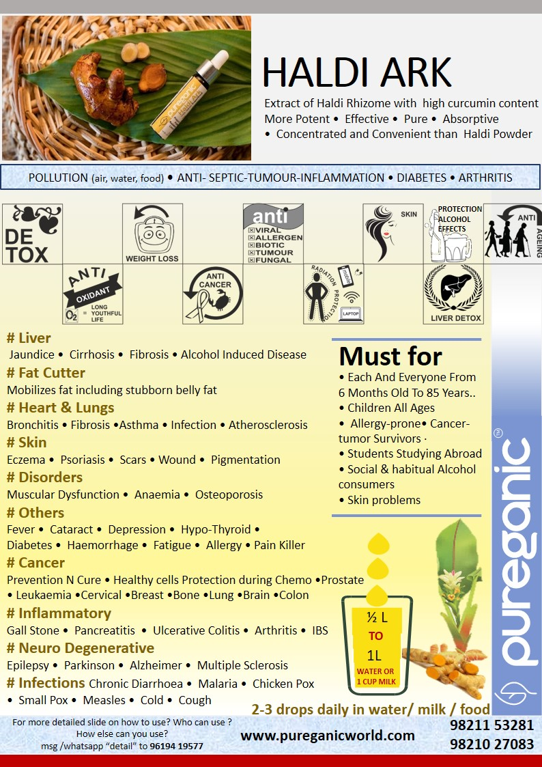

PUREGANIC HALDI (Turmeric) ARK FAQ

- What is so unique about Pureganic Haldi Ark?
  - There are many haldi capsules or haldi extract powders available but we are the only ones in India making liquid extract of the rhizome.

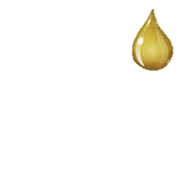

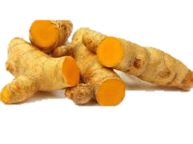
- What is Pureganic Haldi Ark?
  - It is Extract/ concentrate of Haldi / Turmeric in liquid form. It is known to be
    - Anti-Oxidant
    - Antibiotic
    - Anti-viral,
    - Anti-cancer
    - Antiseptic
    - Anti-Allergen
    - Anti-Cholesterol
    - Anti-Tumor
    - Anti-Stress
    - Anti-Inflammatory
    - Anti-fungal

- Why to use Pureganic Haldi Ark?
  - Ark means extract or essence and is very potent where all benefits of the ark are present.
  - Haldi (Turmeric) is known to Detoxify your body specially liver, spleen, pancreas
  - It increases immunity
  - Gives cell level protection against all kinds of Radiation and Pollution

- Why is Pureganic Haldi Ark much more useful than normal haldi powder?
  - Pureganic Haldi Ark is very very potent, pure & unadulterated.
  - It has much more curcumin content than haldi powder.
  - It is easily absorbed by the body.

- What is curcumin?
  - It is the ingredient that gives Haldi it’s powers or benefits.
  - It helps prevent and cure Cancer/Tumor.

- I take fresh Haldi . Why use Pureganic Haldi Ark?
  - For its purity, potency, concentration, convenience and absorptivity.
  - Pureganic haldi ark is made from high power haldi ie haldi with more curcumin than regular haldi available in market
  - 3 drop investment daily to prevent cancer, tumor, liver disease.

- What are the other benefits of Pureganic Haldi Ark k?
  - It controls sugar levels.
  - It detoxifies and protects the liver
  - It is a fat-cutter.
  - Helps with arthritis, anaemia, osteoporosis, cataract, hypothyroid, paikin son, Alzheimer and Epilepsy.
  - Acts as in anti-aging, anti-cancer and anti-depressant.

- What is the shelf life?

  - This being anti bacterial + anti fungal and also due to the ancient method of making an ark this technically does not spoil for many years.

- Can I have more than 3 drop daily dose? Will it cause harm if I have more than 3 drops?

  - It will not cause any harm if taken more than 3 drop. But in taste one might find it very concentrated and not so pleasant.
  - In fact in case of high cough, cold orc flu we recommend taking 3 drops twice a day.

- What if I mix Pureganic Haldi Ark in single glass instead of half to one liter of water?

  - It will not cause any harm.
  - But in taste one might find it very concentrated and not so pleasant.

- Can I mix Pureganic Haldi Ark with green tea?
  - Yes

- Does the water in which I mix Pureganic Haldi Ark has to be Warm?

  - Not necessary. Water temperature can be anything even room temperature.
  - In fact it tastes like a wonderful mocktail in slightly chilled water.

- Can I mix Pureganic Tulsi Ark and Pureganic Haldi Ark Together in the same water?

  - Yes You can.

- Can I give Pureganic Haldi Ark to infants and children?

  - Yes you can.
  - For very small children that is below a year give half the daily dose per day.
  - That is make Haldi water with 1 drop and then give the child.
  - To school going children many mothers add in their water bag

- Can I use it elsewhere beside oral consumption?

  - Yes. Apply on skin for best results
  - Read details given below in this PDF under How to Use

- Can children have Pureganic Haldi Ark?
  - Yes children can have it.
  - People of all age can have it

- How to Consume Pureganic Haldi Ark?
  - Daily add 3 drops Pureganic Haldi Ark in water, milk, Green tea Smoothies, juices

- Does Pureganic Haldi Ark help in Weight Loss
  - Haldi is avery well known fat cutter and so It helps in Weight Loss

- Is Pureganic Haldi Ark beneficial for beauty?
  - Yes.
  - Take 2-3 drops and directly apply to face
  - Or add to face mask for pigmentaion & blemishless skin,

- Is Pureganic Haldi Ark a medicine?
  - No, it is not a medicine.
  - It is day today food made of natural ingredients.

- Will Pureganic Haldi Ark interfere with the medications I am are presently taking?
  - No. It is made from natural haldi with no preservatives or chemicals added.
  - It is normal food stuff.

- How is Pureganic Haldi Ark beneficial for the occasional drinker?
  - Everyone is aware of the effects of alcohol on the liver.
  - Pureganic Haldi Ark detoxifies the liver and protects it from adverse effects
  - Prevents from any alcohol induced liver diseases, jaundice fibrosis

- Benefits of Pureganic Haldi Ark for neurodegenerative disorders
  - Helps prevent Epilepsy, Parkinson, Alzheimer, multiple Sclerosis and other such diseases.

- I take Pureganic Haldi Ark only when I am sick. Is this ok?
  - One must consume Pureganic Ark daily as a part of your diet not just when you are sick.

How To Use

Daily dose : 3 drops anytime during the entire day
How to use
- Use daily and not just when u r sick/ill.
- Daily add 3 drops Pureganic Haldi Ark in half to 1 liter of water (water quantity depends on personal taste). Consume that water at a stretch in the morning or sip through out the day. Can also mix with milk, green-tea, honey, veg juice. Can add in the same water as Pureganic Tulsi Ark
- Water can be any temperature. It is adviced not to heat or cook the ark as there will be nutrient loss
- Mix 3-4 drops with facewash/ face pack for healthy glowing skin
- For any skin related problem consume Pureganic Haldi Ark internally and apply externally for best result

Must For

- Social and heavy drinkers to protect LIVER FROM ALCOHOL effects
- OBESE people as haldi is a fat cutter
- Cancer patients during chemo for detox and protection of healthy cells
- CANCER-TUMOR survivors for preventing relapse
- Skin problems, PIGMENTATION
- STUDENTS STUDING ABROAD OR AWAY FROM HOME
- Arthritis & bones

PUREGANIC Common FAQ

PUREGANIC SUPERFOODS Common FAQ

- What is meant by NATURAL SUPERFOOD?
- These are some very effective FOODS (not medicines) which were used for centuries by our ancestors because they knew its benefits.
- Our genes are used to these foods and we all are familiar with them and know that these are good for us.
- But in today’s age and fast hectic urban lifestyle it is not easy to procure them in unadulterated, pure, unpreserved form and use daily.
- By natural we mean that we don’t add any chemicals, preservatives, flavours, additives to these products.
- We try to bring them to you with all the goodness and nutrients which nature has instilled.
- This is called superfood because of the miraculous powers of its nutrients to cleanse, immunize and fortify human body.

- Why should we use them?
- This is stuff that helps us maintain GOOD HEALTH.
- We live a fast hectic stressful life
  - surrounded by POLLUTION in air, water, food;
  - RADIATION in Mobile, TV, Laptop;
  - Eat JUNK FOOD full of preservatives
  - Do not eat balanced wholesome food
- Pureganic products help you combat all these problems.
- They DE-TOX, IMMUNIZE AND BUILD HEALTH by providing you with all necessary nutrients.

- For HOW LONG should I take them?
  - This is stuff that empowers your diet.
  - Day-today food just like methi-palak.
  - This is not medicine.
  - This is both preventive and curative.
  - Do not use them like medicine just when you are sick or ill.
  - USE THEM DAILY.
  - This is your INVESTMENT IN HEALTH.

- Are these Ayurvedic Medicines?
- NO. these are NOT MEDICINES but day to day food which from centuries is traditionally used for good health

- WHO can take them?
  - EVERYONE right from 6 month baby to 100 year old senior.
  - Except during Pregnancy or some serious condition take advice from our experts or your own doctor

- How long till I can see the RESULTS or benefits?
- The logic behind PUREGANIC is simple.
  - De-tox - remove toxins or “Kachra” from your body.
  - Immunize - fortify and increase the defence mechanism of your body.
  - Build Health - Nature will take it own course and body will take care of its problems and will heal itself.
- Its like servicing your AC. The technician cleans it, fortifies it and it functions better.
- Though results vary from person to person, generally with in a week you see little –little improvements and over a period of couple of months you feel marked difference not only in your problems but also over all stamina and vigor (“sfurti”).
- Since the herbs are pure and potent many people feel a marked difference right from first dose.

- Will it INTERFERE with any OTHER MEDICINE that I am Taking?
  - NO. As this is like normal food there are no side effects and is not harmful in any way.
  - You can continue taking your other medicine just like you used to
  - Our experience has been that as your health improves automatically your physician reduces the dose or stops external medicines.

- What is an ARK? What are ITS ADVANTAGES?
- Ark means extract or concentrate.
- It is an ancient Indian Concept where we capture the essence of any thing keeping all its properties intact.
- Herbal arks are very potent, powerful and hence very very effective.

- Can I MIX any two Arks?
  - Yes.

- HOW should we CONSUME?
  - Arks are very very concentrated extracts and can be consumed AT ANY TIME of the day.
  - Powders like Wheatgrass, Moringa or Purecolo are recommended on empty stomach consumed with 2 glasses of water/ fluid and no food intake of 10-15 mins after consumption. This helps better absorption and so more effective results.
  - On our website we have detailed information of method of consumption. But please feel free to call our Customer Care in case of any doubts.

- What are the SIDE-EFFECTS?
  - Since these are natural herbs just like parsley or methi without chemicals or preservatives they have NO SIDE EFFECTS.
  - If any doubt or problems encountered while consumption please contact us and we will tell you solutions or alternatives.

- Can I give to SMALL CHILDREN?
- Yes. In fact we try to make all our products CHILD-FRIENDLY.
- We feel that adults may compromise on taste or bear discomforts for health but children will not do so.
- Fortifying their health helps in their growth and builds a strong foundation for future health and disease prevention.
- Our products can be given to INFANTS as well. They are very safe. In case of infants it is advisable to dilute the normal dose a little.

- Are Your products BITTER LIKE MOST OF AYURVEDIC STUFF?
  - No. We try to ensure that they are very tasty and refreshing.
  - Our motto is TASTE BHI HEALTH BHI.
  - All our products except Moringa Powder are Yummy and children love them.

- Are they PREVENTIVE OR CURATIVE?
  - Both.

- Can I COSUME AND APPLY EXTERNALLY?
  - YES products like Tulsi Ark, Haldi Ark, Brahmi Nasya, Moringa Oil, Purecolo can definitely be applied externally as well as consumed internally for maximised results.

- What IF I FACE CERTAIN PROBLEMS while consuming?
  - Our preferred methods of consumption are designed for maximised benefits but some people may not have understood correctly or sometimes there is a genuine problem.
  - CALL US ON CUSTOMER CARE we will understand your problem and suggest suitable ALTERNATIVE METHODS OF CONSUMPTION.
  - Such alternatives might be less beneficial then preferred methods but we believe “something is better than nothing”.

- What is UNIQUE about PUREGANIC SUPERFOODS?
Some products like Brahmi Nasya, Herbi GUD, IRONSHAKTI WE ARE THE ONLY / FIRST ONES IN INDIA to make them
We are farmers ourselves and understand plus control raw material from basic
These products are
- perfect fusion of traditional knowledge and modern techniques so we call it
- “ANCIENT FOOD FOR MODERN TIMES”
- aiming at shifting people from “PHARMA”CEUTICAL to “FARMA”CEUTICAL
- Tasty, YUMMY and convenient to use
- Good for all ages so Everyone from the family can use
- Safe and without side-effects
- Preventive and curative

- Why do you recommend so many products for one particular problem / disease?
  - Generally in any medicine multiple drugs are added and combined to give desired results.
  - These drugs are formulated from processed chemicals and herbs and then fused into one tablet.
  - Since we are keeping the herbs in their natural pure form with minimal processing (to ensure there no adverse side effects) we recommend multiple herbs

Please note : All claims based on traditional Indian knowledge

