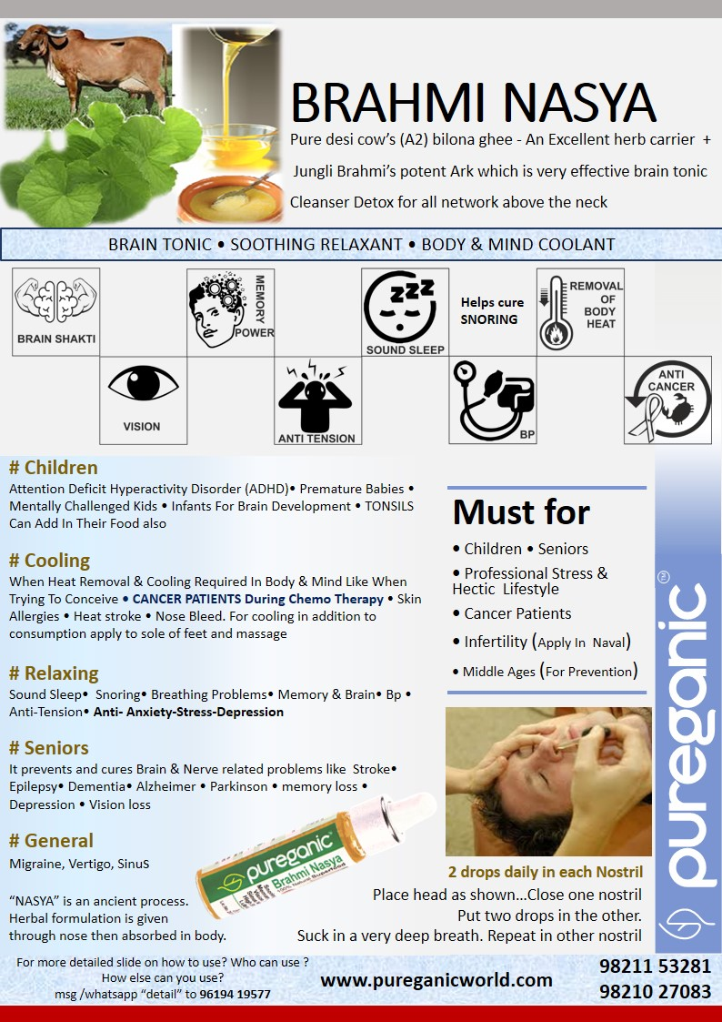
PUREGANIC BRAHMI NASYA (Nasal Drop) FAQ

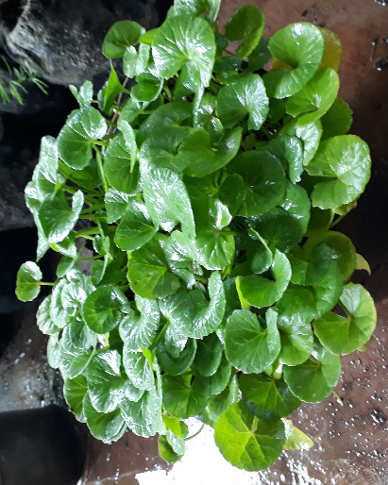
- What is PUREGANIC BRAHMI NASYA?
  - Daily-use nasal drops.
  - Good for all ages from children to senior citizens.

- What is brahmi?
Brahmi herb is a very powerful brain tonic.
  - It also has a very very cooling on the body.
  - For these two properties it was widely used in ancient India.
Brahmi
  - Helps with all problems related to above the shoulder organs
  - Empowers Brain, Memory and Vision
  - High BP, Anti-Stress, Anti- Anxiety, Lack of Sleep, Depression, Snoring
  - Like Nose Block, Nose Bleed, Sinus, Migraine, Vertigo
  - Brain related Parkinson, Alzheimer, Dementia, Memory Loss
  - Trying to conceive ( as it removes excess heat from body)
  - Stroke, Epilepsy
  - Mentally challenged kids

- What is Nasya?
  - In Ayurved "NASA” is a process where in herbal formulation is given through the nose and herbal formulation thus used is called Nasya
  - from the nose it is absorbed in the body especially the blood vessels and the organs above the nose.
  - It aims to nourish and cure all problems above the neck.

- What does PUREGANIC BRAHMI NASYA contain?
  - Contains potent brahmi extract and pure gir cow ghee.
  - These two ingredients are fused by special ancient process which is called “siddh karna”

- What is the role of pure Gir cow ghee
  - This Ghee is made by us in the traditional ayurvedic method it is anti-cancer
  - This ghee is an excellent carrier of herbs that is it helps in proper spread and absorption of the herbs
  - Gir cow ghee is known to be the best in the world.

- Who all can use PUREGANIC BRAHMI NASYA?
  - Safe for children, adults, seniors.
  - All ages can safely use.

- Can you use PUREGANIC BRAHMI NASYA for infants or small children? If yes how?
  - For kids one can apply it to the rim of the nostril
  - Else one can use as 3 drops in Naval (belly Button)
  - For infants or kids one can also consume orally mixed in cooked food

- Does PUREGANIC BRAHMI NASYA help in heat stroke

  - Yes due to its cooling effect.

- How does PUREGANIC BRAHMI NASYA help in High BP or Hypertension
  - For high BP combine PUREGANIC BRAHMI NASYA with PUREGANIC MORINGA OIL.
  - According to Ayurved BP is called due to “vayu” moving in upward direction. Moringa Oil takes care of that and Brahmi Nasya removes the tension and relaxes the brain system.

- Why is PUREGANIC BRAHMI NASYA useful for patients undergoing chemo?
  - It removes heat and toxins from the body
  - It helps person relax and get sound sleep.
  - A relaxedand rested body then speedily starts its own healing process.

- Can I Consume PUREGANIC BRAHMI NASYA Orally and also give to infants and kids?
  - Yes. It is completely edible just like any other food.
  - It gives maximised results as nasal drops.
  - But for some reason one can’t do that than oral consumption is the next best alternative.
  - It is extremely beneficial for Infants and kids as it helps form a strong brain & neural network
  - And improve vision also

- Why should Middle age or Senior Citizens use PUREGANIC BRAHMI NASYA even if they have no health problems?
  - This is a support system for the brain which the engine of your entire body.
  - most appropriate time to use this when you have no problem so that you have no problems when you age. Now a days due to stress and tension brain related problems are more prevalent and this is a simple no harm caution to avoid them.

- Is PUREGANIC BRAHMI NASYA edible?
- Yes it is 100% edible. For infants upto 3 years one can mix in food also for desired results. In adults it is more effective when applied through the nose

- Is Does Brahmi Help in Stroke / Paralysis?
  - Yes. This is a brain and nerve related problem.
  - Stroke / paralysis affected people can contact individually for enhanced remedies.

How To Use

- 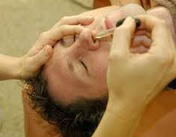 At night lie down with head on the edge of bed or with a small pillow / towel rolled below the neck so that head is in the position with nose up at 45 ⁰
- Close one nostril and in the other put two drops PUREGANIC BRAHMI NASYA breathing deep (sucking up with nose) so herbs go deep into the nose. Repeat with the other nostril.
- Sleep in same position for 5-10 mins.
- Brahmi has a cooling effect so if for some reason you are not comfortable at night you can put drops of PUREGANIC BRAHMI NASYA in afternoon also.
- For kids can apply to rim of nostril also.
- This gives best results in the nose so it is called nasya but for some reason or in case of children one can’t apply in the nose then apply in naval. The benefits will not be as good as nose application but there will be some betterments definitely.
- These are 100% edible. In case of children below 3 years can add a few drops in their cooked food and given. This is excellent for memory and brain development

Must For

- CHILDREN wanting to increase brain - memory power and concentration
- Mentally challenged kids
- Kids with Attention deficit hyperactive disorder (ADD/ADHD)
- Kids or adults wanting to relax or de-stress
- For Tension Free, Sound, Snore-Free Sleep
- Anxiety & Depression prevention and cure
- Must for SENIOR CITIZENS and AFTER MIDDLE AGE to prevent Brain related problems like Stroke Epilepsy, Dementia, Alzheimer, Parkinsons, memory loss in old age
- When Heat removal & cooling required in body as when trying to conceive, CANCER PATIENTS during chemo therapy, Skin Allergies, Heat stroke, BRAIN TUMOR
- Any other problem neck up including BP HYPERTENSION, SNORING, SINUS, VERTIGO, MIGRAINE

PUREGANIC Common FAQ

PUREGANIC SUPERFOODS Common FAQ

- What is meant by NATURAL SUPERFOOD?
- These are some very effective FOODS (not medicines) which were used for centuries by our ancestors because they knew its benefits.
- Our genes are used to these foods and we all are familiar with them and know that these are good for us.
- But in today’s age and fast hectic urban lifestyle it is not easy to procure them in unadulterated, pure, unpreserved form and use daily.
- By natural we mean that we don’t add any chemicals, preservatives, flavours, additives to these products.
- We try to bring them to you with all the goodness and nutrients which nature has instilled.
- This is called superfood because of the miraculous powers of its nutrients to cleanse, immunize and fortify human body.

- Why should we use them?
- This is stuff that helps us maintain GOOD HEALTH.
- We live a fast hectic stressful life
  - surrounded by POLLUTION in air, water, food;
  - RADIATION in Mobile, TV, Laptop;
  - Eat JUNK FOOD full of preservatives
  - Do not eat balanced wholesome food
- Pureganic products help you combat all these problems.
- They DE-TOX, IMMUNIZE AND BUILD HEALTH by providing you with all necessary nutrients.

- For HOW LONG should I take them?
  - This is stuff that empowers your diet.
  - Day-today food just like methi-palak.
  - This is not medicine.
  - This is both preventive and curative.
  - Do not use them like medicine just when you are sick or ill.
  - USE THEM DAILY.
  - This is your INVESTMENT IN HEALTH.

- Are these Ayurvedic Medicines?
- NO. these are NOT MEDICINES but day to day food which from centuries is traditionally used for good health

- WHO can take them?
  - EVERYONE right from 6 month baby to 100 year old senior.
  - Except during Pregnancy or some serious condition take advice from our experts or your own doctor

- How long till I can see the RESULTS or benefits?
- The logic behind PUREGANIC is simple.
  - De-tox - remove toxins or “Kachra” from your body.
  - Immunize - fortify and increase the defence mechanism of your body.
  - Build Health - Nature will take it own course and body will take care of its problems and will heal itself.
- Its like servicing your AC. The technician cleans it, fortifies it and it functions better.
- Though results vary from person to person, generally with in a week you see little –little improvements and over a period of couple of months you feel marked difference not only in your problems but also over all stamina and vigor (“sfurti”).
- Since the herbs are pure and potent many people feel a marked difference right from first dose.

- Will it INTERFERE with any OTHER MEDICINE that I am Taking?
  - NO. As this is like normal food there are no side effects and is not harmful in any way.
  - You can continue taking your other medicine just like you used to
  - Our experience has been that as your health improves automatically your physician reduces the dose or stops external medicines.

- What is an ARK? What are ITS ADVANTAGES?
- Ark means extract or concentrate.
- It is an ancient Indian Concept where we capture the essence of any thing keeping all its properties intact.
- Herbal arks are very potent, powerful and hence very very effective.

- Can I MIX any two Arks?
  - Yes.

- HOW should we CONSUME?
  - Arks are very very concentrated extracts and can be consumed AT ANY TIME of the day.
  - Powders like Wheatgrass, Moringa or Purecolo are recommended on empty stomach consumed with 2 glasses of water/ fluid and no food intake of 10-15 mins after consumption. This helps better absorption and so more effective results.
  - On our website we have detailed information of method of consumption. But please feel free to call our Customer Care in case of any doubts.

- What are the SIDE-EFFECTS?
  - Since these are natural herbs just like parsley or methi without chemicals or preservatives they have NO SIDE EFFECTS.
  - If any doubt or problems encountered while consumption please contact us and we will tell you solutions or alternatives.

- Can I give to SMALL CHILDREN?
- Yes. In fact we try to make all our products CHILD-FRIENDLY.
- We feel that adults may compromise on taste or bear discomforts for health but children will not do so.
- Fortifying their health helps in their growth and builds a strong foundation for future health and disease prevention.
- Our products can be given to INFANTS as well. They are very safe. In case of infants it is advisable to dilute the normal dose a little.

- Are Your products BITTER LIKE MOST OF AYURVEDIC STUFF?
  - No. We try to ensure that they are very tasty and refreshing.
  - Our motto is TASTE BHI HEALTH BHI.
  - All our products except Moringa Powder are Yummy and children love them.

- Are they PREVENTIVE OR CURATIVE?
  - Both.

- Can I COSUME AND APPLY EXTERNALLY?
  - YES products like Tulsi Ark, Haldi Ark, Brahmi Nasya, Moringa Oil, Purecolo can definitely be applied externally as well as consumed internally for maximised results.

- What IF I FACE CERTAIN PROBLEMS while consuming?
  - Our preferred methods of consumption are designed for maximised benefits but some people may not have understood correctly or sometimes there is a genuine problem.
  - CALL US ON CUSTOMER CARE we will understand your problem and suggest suitable ALTERNATIVE METHODS OF CONSUMPTION.
  - Such alternatives might be less beneficial then preferred methods but we believe “something is better than nothing”.

- What is UNIQUE about PUREGANIC SUPERFOODS?
Some products like Brahmi Nasya, Herbi GUD, IRONSHAKTI WE ARE THE ONLY / FIRST ONES IN INDIA to make them
We are farmers ourselves and understand plus control raw material from basic
These products are
- perfect fusion of traditional knowledge and modern techniques so we call it
- “ANCIENT FOOD FOR MODERN TIMES”
- aiming at shifting people from “PHARMA”CEUTICAL to “FARMA”CEUTICAL
- Tasty, YUMMY and convenient to use
- Good for all ages so Everyone from the family can use
- Safe and without side-effects
- Preventive and curative

- Why do you recommend so many products for one particular problem / disease?
  - Generally in any medicine multiple drugs are added and combined to give desired results.
  - These drugs are formulated from processed chemicals and herbs and then fused into one tablet.
  - Since we are keeping the herbs in their natural pure form with minimal processing (to ensure there no adverse side effects) we recommend multiple herbs

Please note : All claims based on traditional Indian knowledge

