PUREGANIC DESI COW’S BILONA GHEE FAQ

- How is PUREGANIC DESI COW’S BILONA GHEE made?

  - We make ghee the traditional ayurvedic way
  - by fermenting cream from desi cows A2 milk (no steroid / hormone injection used)
  - White “Makhan” is churned out and buttermilk is removed
  - This “Makhan” is heated to make ghee
  - Heating removes milk allergens.
  - The fermentation process adds important Nutrients which are missing in commercially produced ghee
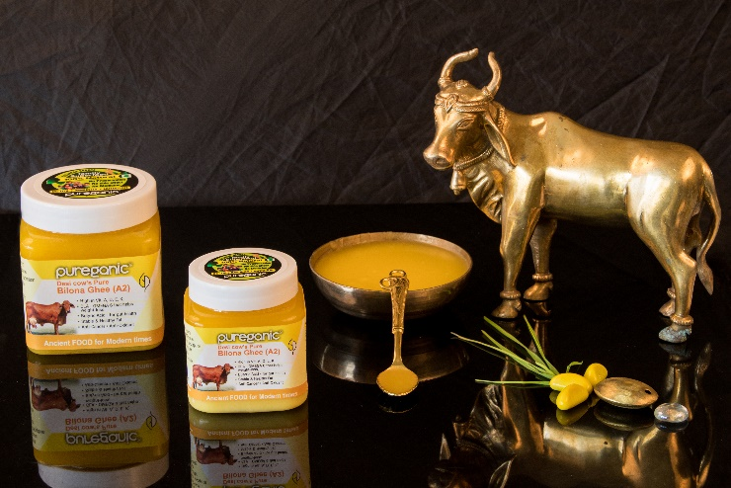
- What is bilona ghee?

  - This is ghee made by the traditional process where fermentation and churning (bilona) are two compulsory steps.

- How is PUREGANIC DESI COW’S BILONA GHEE different from other commercially available ghee?

  - Most of the commercial brands directly process cream from any cow (desi or jersey. Non-desi cow’s ghee contains a protein A1 which is believed to be cancer causing) to manufacture ghee on large scale at low cost .
  - To increase production the animals are given hormone/steroid injections which cause hormonal imbalance, POCD, cancer, tumors in humans .
  - They skip the time consuming costly process of fermenting and heating. Instead milk cream is directly churned to make ghee which is not ghee by Ayurvedic definition but technically milk fat with almost no health benefits.

- Why is PUREGANIC DESI COW’S BILONA GHEE costlier?

  - Most of the commercial dairies skip the two steps of fermentation and heating as they are time consuming and costly
  - Their ghee is made from milk cream
  - Even Jersey cows (Non-desi cow’s ghee contains a protein A1 which is cancer causing) with A1 milk are used which give more milk
  - So their ghee is cheap but lacking most of the health benefits
  - We use milk from desi Gir Cows.
  - No hormone injections given to cows.
  - It takes us 30 litres of milk to make 1 KG ghee
  - Also we sell in kg and most of the dairies sell in litres. 1 litre = 900 gms. so we give more ghee

- What are the benefits of PUREGANIC DESI COW’S BILONA GHEE?

  - It is Anti-Oxidant and Anti-Cancer
  - It is a very stable fat Ghee has high boiling point. On heating no free radicals (which cause oxidation, aging and cancer) are released
  - It is a good absorbent. food supplements, herbs, spices or medicines taken with ghee multiplies effectiveness

- What are essential nutrients of PUREGANIC DESI COW’S BILONA GHEE (A2)

  - Vitamin A in ghee is biosouble hence more absorbed n effective..It is good for eyes, hair, fertility , stamina, liver health, hormonal balance
  - CLA – Conjugal Linoleic Acid prevents diabetes, cancer, tumour, hardening of arteries, blockage. It is main component of weight loss and body building supplements
  - Butyric Acid immunity, digestion, anti-inflammatory, ulcer, strengthens intestines, increases insulin sensitivity, metabolism.
  - Vit K is the shuttle that transports calcium to the bones. Without it no matter how much calcium you eat it will be flushed by kidneys
  - Vit D & E

- How does PUREGANIC DESI COW’S BILONA GHEE (A2) help Senior citizens?
It helps in
Brain N Memory Power,
- Insomania
- Ulcer.
- Alziemer,
- Dimentia,
- Joint Pain,
- Bone Strength
- Digestion,
- Immunity,
- Gut N Liver Health

- How does PUREGANIC DESI COW’S BILONA GHEE (A2) help youngsters and middle ages?
Helps in
- Omega 3, 6
- Heart Health,
- Sperm Count,
- Fertility,
- Immune System,
- Skin
- Hair,
- Anti Cancer,
- Stubborn Belly Fat
- Fat Mobilizer,
- De –Stress,
- Piles,
- Detox,
- Anti Viral,
- Anti Oxidant
- How does PUREGANIC DESI COW’S BILONA GHEE (A2) help Kids
- Brain Development
- Memory Power, Concentration,
- Weak Appetite,
- Baby Massage,
- Eyesight
- Bone Strength,
- Physical Growth,
- Energiser,
- Immunity,
Dieticians like Rujuta Diweker are recommending the use of ghee for weight management and good health

- What are the health benefits of PUREGANIC DESI COW’S BILONA GHEE (A2)?
  - An excellent home remedy to improve digestion and curing constipation.
  - It helps to secret enzymes that digest the food.
  - Normalises Vata and Pitta. Nourishes the body
  - It is best for cancer patients. Having the power to stop growing cancer cells
  - Improves sperm count and strengthens sexual power
  - beneficial for curing thyroid dysfunction
  - reduces bad cholesterol
  - good for hair and skin, anti-aging
  - Vitamin A helps in cellular growth, healthy teeth and bones , vision (keep eyes moist)
  - Vitamin D helps improve calcium absorption and prevent body inflammation
  - Vitamin E enhances wound healing process and immune system
  - Vitamin K helps in regulating blood clotting activities
  - Aids in lubrication of connective tissues for people suffering from joint pain
  - An immune enhancing food due to its antiviral, antifungal properties
  - Ghee is also known for its impact on tone and strength of the voice!!
  - It is used as a topical application for heel cracks, over wounds, burn

- Why should PUREGANIC DESI COW’S BILONA GHEE (A2) Be Used During Pregnancy ?

Bilona ghee during and after pregnancy has been always an ancient custom which todays young women neglect .
  - It helps in relieving constipation in pregnancy
  - It helps in development of baby’s brain
  - It helps in easing labour
  - It helps in improving the digestion
  - It helps in nourishing the baby
  - It is said that Vitamin K present in PUREGANIC DESI COW’S BILONA GHEE (A2) helps build good features of the child.
  - According to ayurved it is good for the development of the brain and nerve network of the child
  - Vit d and k help provide much needed calcium to the mother and the child

In a nut shell
  - 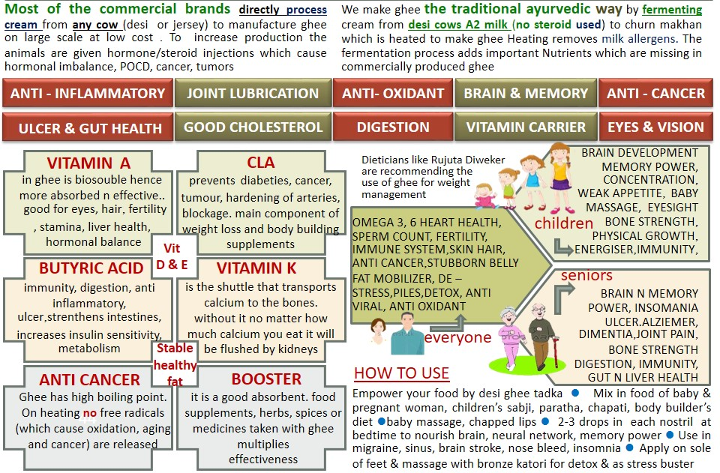

How To Use

Besides in diet How else to use ghee
- 2 drops in each nostril at bedtime nourishes brain, memory, nerve network, vision, migraine, sinus, helps insomnia, prevents n cures stroke
- apply on sole of feet n massage for 15-20 min with bronze (kansa) katori to detox and as stress buster. You will see that in 15 min it becomes all black with all the toxins removed
- massage the baby for strong bones and glowing skin
- consume in pregnancy to develop brain of the child
- best food for muscle development
- apply in belly button for detox lubrication n clearing of all the blood vessels
- use on chapped lips as moisturiser

Must For

KIDS
SENIOR CITIZENS
BODY BUILDERS
PREGNANT WOMEN
INFANTS
CANCER PATIENTS
DIGESTION , PILES
ANTI-CANCER

PUREGANIC Common FAQ

- What is meant by NATURAL SUPERFOOD?

- These are some very effective FOODS (not medicines) which were used for centuries by our ancestors because they knew its benefits.
- Our genes are used to these foods and we all are familiar with them and know that these are good for us.
- But in this age of fast hectic urban lifestyle it is not easy to procure them in unadulterated, pure, unpreserved form and use daily.
- By natural we mean that we don’t add any chemicals, preservatives, flavours, additives to these products.
- We try to bring them to you with all the goodness and nutrients which nature has instilled.
- This is called superfood because of the miraculous powers of its nutrients to cleanse, immunize and fortify human body.

- Why should we use them?

- This is stuff that helps us maintain GOOD HEALTH.
- We live a fast hectic stressful life
  - surrounded by POLLUTION in air, water, food;
  - RADIATION in Mobile, TV, Laptop;
  - Eat JUNK FOOD full of preservatives
  - Do not eat balanced wholesome food
- Pureganic products help you combat all these problems.
- They DE-TOX, IMMUNIZE AND STRENGTHEN by providing you with all necessary nutrients.

- For HOW LONG should I take them?

  - This is stuff that empowers your diet.
  - Day-today food just like methi-palak.
  - This is not medicine.
  - This is both preventive and curative.
  - Do not use them like medicine just when you are sick or ill.
  - USE THEM DAILY.
  - This is your INVESTMENT IN HEALTH.

- WHO can take them?

  - EVERYONE right from 6 month baby to 100 year old senior.
  - Except during Pregnancy or some serious condition take advice from our experts or your own doctor .

- How long till I can see the RESULTS or benefits?

- The logic behind PUREGANIC is simple.
  - De-tox - remove toxins or “Kachra” from your body.
  - Immunize - fortify and increase the defence mechanism of your body.
  - Nature will take it own course and body will take care of its problems and will heal itself.
- Its like servicing your AC. The technician cleans it, fortifies it and it functions better.
- Though results vary from person to person generally with in a week you see little –little improvements and over a period of couple of months you feel marked difference not only in your problems but also over all stamina and vigor (“sfurti”).
- Since the herbs are pure and potent many people feel a marked difference right from first dose.

- Will it INTERFERE with any OTHER MEDICINE that I am Taking?

  - NO. As this is like normal food there are no side effects and is not harmful in any way.
  - You can continue taking your other medicine just like you used to
  - Our experience has been that as your health improves automatically your physician reduces the dose or stops external medicines.

- What is an ARK? What are ITS ADVANTAGES?
- Ark means extract or concentrate.
- It is an ancient Indian Concept where we capture the essence of any thing keeping all its properties intact.
- Herbal arks are very potent, powerful and hence very very effective.

- Can I MIX any two Arks?
  - Yes.

- HOW should we CONSUME?
  - Arks are very very concentrated extracts and can be consumed AT ANY TIME of the day.
  - Powders like Wheatgrass, Moringa or Purecolo are recommended on empty stomach consumed with 2 glasses of water/ fluid and no food intake of 10-15 mins after consumption. This helps better absorption and so more effective results.
  - On our website we have detailed information of method of consumption. But please feel free to call our Customer Care in case of any doubts.

- What are the SIDE-EFFECTS?
  - Since these are natural herbs just like parsley or methi without chemicals or preservatives they have NO SIDE EFFECTS.
  - If any doubt or problems encountered while consumption please contact us and we will tell you solutions or alternatives.

- Can I give to SMALL CHILDREN?
- Yes. In fact we try to make all our products CHILD-FRIENDLY.
- We feel that adults may compromise on taste or bear discomforts for health but children will not do so.
- Fortifying their health helps in their growth and builds a strong foundation for future health and disease prevention.
- Our products can be given to INFANTS as well. They are very safe. In case of infants it is advisable to dilute the normal dose a little.

- Are Your products BITTER LIKE MOST OF AYURVEDIC STUFF?
  - No. We try to ensure that they are very tasty and refreshing.
  - Our motto is TASTE BHI HEALTH BHI.
  - All our products except Moringa Powder are Yummy and children love them.

- Are they PREVENTIVE OR CURATIVE?
  - Both.

- Can I COSUME AND APPLY EXTERNALLY?
  - YES products like Tulsi Ark, Haldi Ark, Brahmi Nasya, Moringa Oil, Purecolo can definitely be applied externally as well as consumed internally for maximised results.

- What IF I FACE CERTAIN PROBLEMS while consuming?
  - Our preferred methods of consumption are designed for maximised benefits but some people may not have understood correctly or sometimes there is a genuine problem.
  - CALL US ON CUSTOMER CARE we will understand your problem and suggest suitable ALTERNATIVES.
  - Such alternatives might be less beneficial then preferred methods but we believe “something is better than nothing”.

- What is UNIQUE about PUREGANIC SUPERFOODS?
Some products like Brahmi Nasya, Herbi GUD WE ARE THE ONLY / FIRST ONES IN INDIA to make them
We are farmers ourselves and understand plus control raw material from basic
These products are
- perfect fusion of traditional knowledge and modern techniques so we call it
- “ANCIENT FOOD FOR MODERN TIMES”
- aiming at shifting people from “PHARMA”CEUTICAL to “FARMA”CEUTICAL
- Tasty, YUMMY and convenient to use
- Good for all ages so Everyone from the family can use
- Safe and without side-effects
- Preventive and curative

- Why do you recommend so many products for one particular problem / disease?
  - Generally in any medicine multiple drugs are added and combined to give desired results.
  - These drugs are formulated from processed chemicals and herbs and then fused into one tablet.
  - Since we are keeping the herbs in their natural pure form (to ensure there no adverse side effects) we recommend multiple herbs

