PUREGANIC CALCIYUM FAQ

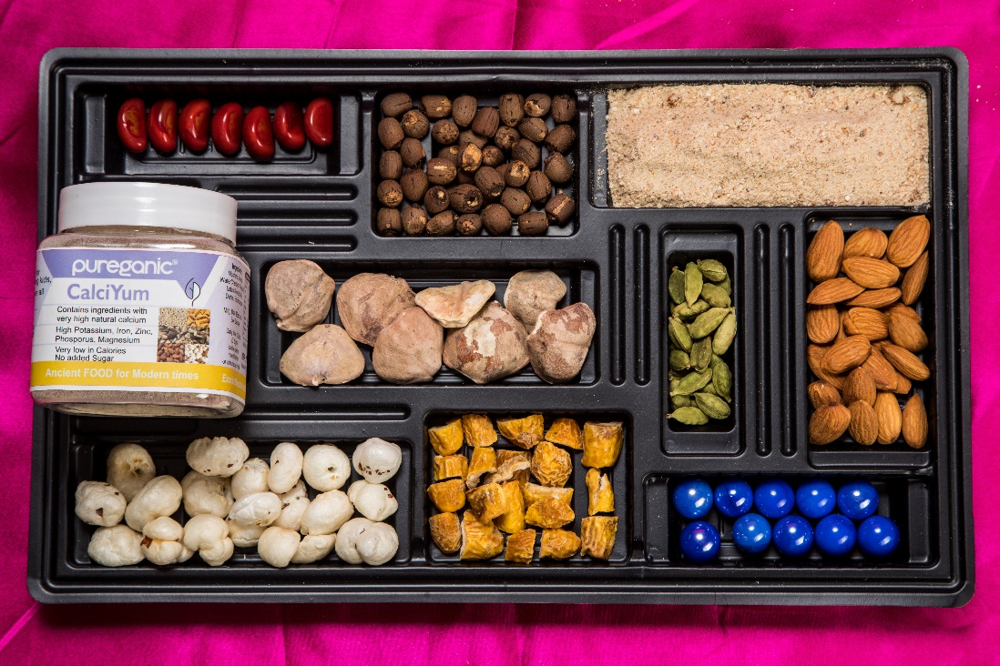

- What is PUREGANIC CALCIYUM POWDER?
  - It is made out of foods that are naturally high in calcium but very very low in calories

- How does PUREGANIC CALCIYUM POWDER taste
  - PUREGANIC CALCIYUM POWDER is very Yummy and tasty.

- Does PUREGANIC CALCIYUM POWDER contain added sugar?
  - No. There is no added sugar or artificial sweetners

- What do you mean by Natural?
  - There are no additives, preservatives or chemicals added in PUREGANIC CALCIYUM POWDER. For flavour also we use natural cardamom (Elaichi ) powder

- What is the benefit of PUREGANIC CALCIYUM POWDER over calcium supplement tablets?
  - Naturally occurring calcium is easy to absorb in the body.
  - Many a times artificial supplements contain calcium which can’t be absorbed easily by the body and kidneys have to overwork to flush it out.
  - It may even cause Kidney stones.
  - PUREGANIC CALCIYUM POWDER being normal food is free of side effects and is tasty also
  - It is also good for weight watchers as it is almost nil in calories.

- What are the other health benefits of PUREGANIC CALCIYUM POWDER
  - Besides being good source of natural calcium it is also contains good measure of magnesium and potassium

How To Use

Daily dose : 1 tea spoon daily any time between meals. There is no harm in taking more that is upto 3 tea spoon
How to Consume:
- Eat directly as mouth fresheners (mukhwas)
- mix in a cup of milk
- Add in salad / sandwich/ breakfast cereal.
- Sprinkle on cooked food as sugar alternate
- 3tsp in a cup of milk makes porridge like consistency complete micromeal. Can be consumed as “faral” in Fasting (upwas)
- Weight watchers can mix in skim milk . It serves as a very very low cal micro meal

Must For

- WOMEN ALL AGES
- GROWING KIDS
- SENIORS
- WEAK BONES
- WEIGHT WATCHERS

PUREGANIC Common FAQ

PUREGANIC SUPERFOODS Common FAQ

- What is meant by NATURAL SUPERFOOD?
- These are some very effective FOODS (not medicines) which were used for centuries by our ancestors because they knew its benefits.
- Our genes are used to these foods and we all are familiar with them and know that these are good for us.
- But in today’s age and fast hectic urban lifestyle it is not easy to procure them in unadulterated, pure, unpreserved form and use daily.
- By natural we mean that we don’t add any chemicals, preservatives, flavours, additives to these products.
- We try to bring them to you with all the goodness and nutrients which nature has instilled.
- This is called superfood because of the miraculous powers of its nutrients to cleanse, immunize and fortify human body.

- Why should we use them?
- This is stuff that helps us maintain GOOD HEALTH.
- We live a fast hectic stressful life
  - surrounded by POLLUTION in air, water, food;
  - RADIATION in Mobile, TV, Laptop;
  - Eat JUNK FOOD full of preservatives
  - Do not eat balanced wholesome food
- Pureganic products help you combat all these problems.
- They DE-TOX, IMMUNIZE AND BUILD HEALTH by providing you with all necessary nutrients.

- For HOW LONG should I take them?
  - This is stuff that empowers your diet.
  - Day-today food just like methi-palak.
  - This is not medicine.
  - This is both preventive and curative.
  - Do not use them like medicine just when you are sick or ill.
  - USE THEM DAILY.
  - This is your INVESTMENT IN HEALTH.

- Are these Ayurvedic Medicines?
- NO. these are NOT MEDICINES but day to day food which from centuries is traditionally used for good health

- WHO can take them?
  - EVERYONE right from 6 month baby to 100 year old senior.
  - Except during Pregnancy or some serious condition take advice from our experts or your own doctor

- How long till I can see the RESULTS or benefits?
- The logic behind PUREGANIC is simple.
  - De-tox - remove toxins or “Kachra” from your body.
  - Immunize - fortify and increase the defence mechanism of your body.
  - Build Health - Nature will take it own course and body will take care of its problems and will heal itself.
- Its like servicing your AC. The technician cleans it, fortifies it and it functions better.
- Though results vary from person to person, generally with in a week you see little –little improvements and over a period of couple of months you feel marked difference not only in your problems but also over all stamina and vigor (“sfurti”).
- Since the herbs are pure and potent many people feel a marked difference right from first dose.

- Will it INTERFERE with any OTHER MEDICINE that I am Taking?
  - NO. As this is like normal food there are no side effects and is not harmful in any way.
  - You can continue taking your other medicine just like you used to
  - Our experience has been that as your health improves automatically your physician reduces the dose or stops external medicines.

- What is an ARK? What are ITS ADVANTAGES?
- Ark means extract or concentrate.
- It is an ancient Indian Concept where we capture the essence of any thing keeping all its properties intact.
- Herbal arks are very potent, powerful and hence very very effective.

- Can I MIX any two Arks?
  - Yes.

- HOW should we CONSUME?
  - Arks are very very concentrated extracts and can be consumed AT ANY TIME of the day.
  - Powders like Wheatgrass, Moringa or Purecolo are recommended on empty stomach consumed with 2 glasses of water/ fluid and no food intake of 10-15 mins after consumption. This helps better absorption and so more effective results.
  - On our website we have detailed information of method of consumption. But please feel free to call our Customer Care in case of any doubts.

- What are the SIDE-EFFECTS?
  - Since these are natural herbs just like parsley or methi without chemicals or preservatives they have NO SIDE EFFECTS.
  - If any doubt or problems encountered while consumption please contact us and we will tell you solutions or alternatives.

- Can I give to SMALL CHILDREN?
- Yes. In fact we try to make all our products CHILD-FRIENDLY.
- We feel that adults may compromise on taste or bear discomforts for health but children will not do so.
- Fortifying their health helps in their growth and builds a strong foundation for future health and disease prevention.
- Our products can be given to INFANTS as well. They are very safe. In case of infants it is advisable to dilute the normal dose a little.

- Are Your products BITTER LIKE MOST OF AYURVEDIC STUFF?
  - No. We try to ensure that they are very tasty and refreshing.
  - Our motto is TASTE BHI HEALTH BHI.
  - All our products except Moringa Powder are Yummy and children love them.

- Are they PREVENTIVE OR CURATIVE?
  - Both.

- Can I COSUME AND APPLY EXTERNALLY?
  - YES products like Tulsi Ark, Haldi Ark, Brahmi Nasya, Moringa Oil, Purecolo can definitely be applied externally as well as consumed internally for maximised results.

- What IF I FACE CERTAIN PROBLEMS while consuming?
  - Our preferred methods of consumption are designed for maximised benefits but some people may not have understood correctly or sometimes there is a genuine problem.
  - CALL US ON CUSTOMER CARE we will understand your problem and suggest suitable ALTERNATIVE METHODS OF CONSUMPTION.
  - Such alternatives might be less beneficial then preferred methods but we believe “something is better than nothing”.

- What is UNIQUE about PUREGANIC SUPERFOODS?
Some products like Brahmi Nasya, Herbi GUD, IRONSHAKTI WE ARE THE ONLY / FIRST ONES IN INDIA to make them
We are farmers ourselves and understand plus control raw material from basic
These products are
- perfect fusion of traditional knowledge and modern techniques so we call it
- “ANCIENT FOOD FOR MODERN TIMES”
- aiming at shifting people from “PHARMA”CEUTICAL to “FARMA”CEUTICAL
- Tasty, YUMMY and convenient to use
- Good for all ages so Everyone from the family can use
- Safe and without side-effects
- Preventive and curative

- Why do you recommend so many products for one particular problem / disease?
  - Generally in any medicine multiple drugs are added and combined to give desired results.
  - These drugs are formulated from processed chemicals and herbs and then fused into one tablet.
  - Since we are keeping the herbs in their natural pure form with minimal processing (to ensure there no adverse side effects) we recommend multiple herbs

Please note : All claims based on traditional Indian knowledge

